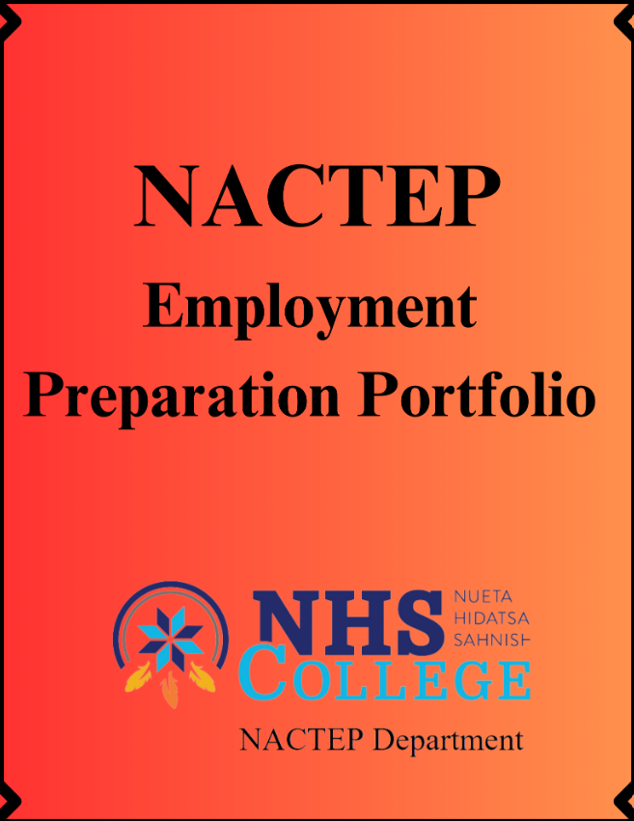
NACTEP Employment Preparation Portfolio
The purpose of this Portfolio is to help you prepare for seeking employment after or right before graduation. You will also be able to use the information included here to apply to different colleges if you choose to continue your education after you leave NHSC. You can also use this to organize and store your record of achievements such as: Copies of diplomas, official transcripts, professional development certificates and records of significant projects that you’ve completed. Below is a list of things we would like you to add into the portfolio by the time that you graduate from NHSC. You will be provided with a binder, resume paper, and sheet protectors to store the information. It will be yours to keep and we will help you work through the activities throughout your time as an NHSC NACTEP student.
You should create a table of contents for what you are able to gather for the binder toward completion of the project. This will allow you to have the most accurate picture of what the binder contains as well as where it is located in the binder. You will need to create a cover page label for the top of the binder, i.e. James Free Portfolio 2021. You will place it in the cover of the binder. Here is what we would like you to include at a minimum in the binder. *Please plan to keep all the following documents in an electronic version so that you are able to reference them, reprint and edit them at a later time.
Your Resume: Job Service/ Indeed/ Zip Recruiter are all online easy to use resources. Where you can enter the information and print it from the site. And return to it later to revise it over the years. We will provide you with a resume template.
Your Bio: Write a statement about what you went to school for and how you intend to use it to accomplish your career or community goals.
Cover Letter: When it is time to apply for a job you will do a cover letter that incorporates your bio and how the organization you are looking to work for fits your goals and why you would like to work for the company. This letter will be different for each company, or you can create one that gives an overall statement of your capabilities.
Transcripts: (unofficial and official -sealed). Employers like to see how well you did in your coursework. Most importantly they look for the degree granting date make sure you have the most recent one that states that your degree was conferred.
Work History: Included is a space for you to record your work history. Often times job applications ask for work history. Along with supervisors names etc. Instead of having to look it up every time you can simply have it written and on hand at any given time.
Reference List or Letters: Job applications will often ask for references. People who know you in a professional or academic capacity. This should be a non-relative to you. And make sure to let the reference know you are listing them as a reference before adding them to your master list. Letters: If you have some that were written for you from school or can think of someone to write you one about how you know the person and what they think of your future goals and aspirations. You might ask them to write you a reference letter to keep in your portfolio the more you have, the better.
Capstone Paper or Project: In your final semester or assessment course keep a copy of your final project or paper.
Diplomas: H.S., GED, College – copies if you frame the originals, or originals if you do not frame them.

Employment History
List your complete work history in reverse chronological order, begin with your current or most recent job. Include all jobs part-time and full-time. Be sure to list any military service, Internships, apprenticeships, community service and volunteer work. This is going to help you prepare to apply for jobs. It will also be helpful to reference as you create your resume. Most applications request a minimum of the company name, supervisor, primary responsibilities, and accomplishments. Having this handy can often help you during the interview process to explain any gaps in employment. Feel free to note your periods of college attendance here as well.

Job Title

Name of Employer/ organization
Description of Duties

Start to End Dates
Name of Supervisor
Company Address

Supervisor Phone #
Supervisor Email Address

Job Title

Name of Employer/ organization
Description of Duties

Start to End Dates
Name of Supervisor
Company Address

Supervisor Phone #
Supervisor Email Address

Job Title

Name of Employer/ organization
Description of Duties

Start to End Dates
Name of Supervisor
Company Address

Supervisor Phone #
Supervisor Email Address

Job Title

Name of Employer/ organization
Description of Duties

Start to End Dates
Name of Supervisor
Company Address

Supervisor Phone #
Supervisor Email Address

Job Title

Name of Employer/ organization
Description of Duties

Start to End Dates
Name of Supervisor
Company Address

Supervisor Phone #
Supervisor Email Address

Job Title

Name of Employer/ organization
Description of Duties

Start to End Dates
Name of Supervisor
Company Address

Supervisor Phone #
Supervisor Email Address
Reference List
Your reference list should be comprised of both professional and personal references. These again, should not be family or friends. These people will be able to speak to the quality of your character, work ethic, or community commitment and engagement. Always plan to notify the person before putting them on your application that way they are prepared to answer questions about you. Most often employment applications will ask for 2-3 personal or professional references. This list will also come in handy if you decide to continue your education further. Many college applications request personal references. Be sure to revise this list over time, as you grow in your career or academic career. You will want to provide individuals have the most up to date reflection of yourself.

First and Last Name
Length of relationship
Type of relationship
Phone Number
Email
Mailing Address

First and Last Name
Length of relationship
Type of relationship
Phone Number
Email
Mailing Address

First and Last Name
Length of relationship
Type of relationship
Phone Number
Email
Mailing Address
First and Last Name
Length of relationship
Type of relationship
Phone Number
Email
Mailing Address

First and Last Name
Length of relationship
Type of relationship
Phone Number
Email
Mailing Address

First and Last Name
Length of relationship
Type of relationship
Phone Number
Email
Mailing Address

First and Last Name
Length of relationship
Type of relationship
Phone Number
Email
Mailing Address

12 Career Ready Practices
This framework is provided by the North Dakota Career & Technical Education Department. The framework was informed by the work of AdvanceCTE where state leaders convene to discuss Connecting Learning to Work. It is a representation of what it will require of you to be a contributing professional in your chosen field of work. Please review each of these and do a self-assessment and develop a personal plan to make personal goals where appropriate. Visit careertech.org or cte.nd.gov/career-ready-practices for more information on career preparedness.

- Act as a Responsible and Contributing Citizen and Employee

Career-ready individuals understand the obligations and responsibilities of being a member of a community and demonstrate this understanding every day through their interactions with others. They are conscientious of the impacts of their decisions on others and the environment around them, think about the near-term and long-term consequences of their actions, and seek to act in ways that contribute to the betterment of their teams, families, community, and workplace. They are reliable and consistent in going beyond the minimum expectation and in participating in activities that serve the greater good.

- Apply Appropriate Academic and Technical Skills

Career-ready individuals readily access and use the knowledge and skills acquired through experience and education to be more productive. They make connections between abstract concepts with real-world applications and make correct insights about when it is appropriate to apply the use of an academic skill in a workplace situation.

- Attend to Personal Health and Financial Well-Being

Career-ready individuals understand the relationship between personal health, workplace performance, and personal well-being; they act on that understanding to regularly practice health diet, exercise and mental health activities. Career-ready individuals also take regular action to contribute to their personal financial well-being, understanding that personal financial security provides the peace of mind required to contribute more fully to their own career success.

- Communicate Clearly, Effectively, and with Reason

Career-ready individuals communicate thoughts, ideas, and action plans with clarity, whether using written, verbal, and/or visual methods. They communicate in the workplace with clarity and purpose to make maximum use of their own and others’ time. They are excellent writers; they master conventions, word choice and organization and use effective tone and presentation skills to articulate ideas. They are skilled at interacting with others; they are active listeners and speak clearly and with purpose. Career-ready individuals think about the audience for their communication and prepare accordingly to ensure the desired outcome.

- Consider the Environmental, Social, and Economic Impacts of Decisions

Career-ready individuals understand the interrelated nature of their actions and regularly make decisions that positively impact and/or mitigate negative impact on other people, organizations and the environment. They are aware of and utilize new technologies, understandings, procedures, materials and regulations affecting the nature of their work as it relates to the impact on the social condition, the environment and profitability of the organization.

- Demonstrate Creativity and Innovation

Career-ready individuals regularly think of ideas that solve problems in new and different ways, and they contribute those ideas in a useful and productive manner to improve their organization. They can consider unconventional ideas and suggestions as solutions to issues, tasks or problems, and they discern which ideas and suggestions will add greatest value. They seek new methods, practices and ideas from a variety of sources and seek to apply those ideas to their own workplace. They take action on their ideas and understand how to bring innovation to an organization.

- Employ Valid and Reliable Research Strategies

Career-ready individuals are discerning in accepting and using new information to make decisions, change practices, or inform strategies. They use a reliable research process to search for new information and evaluate the validity of sources when considering the use and adoption of external information or practices. They use an informed process to test new ideas, information, and practices in their workplace situation.

- Utilize Critical Thinking to Make Sense of Problems and Persevere in Solving Them

Career-ready individuals readily recognize problems in the workplace, understand the nature of the problem, and devise effective plans to solve the problem. They are aware of problems when they occur, quickly take action to address the problem, thoughtfully investigate the root cause of the problem prior to introducing solutions, and carefully consider the options to solve the problem. Once a solution is agreed upon, they follow through to ensure the problem is solved, whether through their own actions or the actions of others.

- Model Integrity, Ethical Leadership, and Effective Management

Career-ready individuals consistently act in ways that align to personal and community-held ideals and principles while employing strategies to positively influence others in the workplace.
They have a clear understanding of integrity and act on this understanding in every decision. They use a variety of means to positively impact the direction and actions of a team or organization, and they apply insights into human behavior to change others’ actions, attitudes, and/or beliefs. They recognize the near-term and long-term effects that management’s actions and attitudes can have on productivity, morale, and organizational culture.

- Plan Education and Career Path Aligned to Personal Goals

Career-ready individuals take personal ownership of their own educational and career goals, and they regularly act on a plan to attain these goals. They understand their own career interests, preferences, goals, and requirements. They have perspective regarding the pathways available to them and the time, effort, experience, and other requirements to pursue each, including a path of entrepreneurship. They recognize the value of each step in the educational and experiential process, and they recognize that nearly all career paths require ongoing education and experience. They seek counselors, mentors, and other experts to assist in the planning and execution of career and personal goals.

- Use Technology to Enhance Productivity

Career-ready individuals find and maximize the productive value of existing and new technology to accomplish workplace tasks and solve workplace problems. They are flexible and adaptive in acquiring and using new technology, being proficient with ubiquitous technology applications. They understand the inherent risks, personal and organizational, of technology applications, and they take actions to prevent or mitigate these risks.

- Work Productively in Teams While Using Cultural/Global Competence

Career-ready individuals positively contribute to every team whether formal or informal. They apply an awareness of cultural differences to avoid barriers to productive and positive interaction. They find ways to increase the engagement and contribution of all team members. They plan and facilitate effective team meetings.

Job Search Worksheet
As you begin to search for Jobs, use this as a place to track where you are finding the jobs that you would like to apply for. Job searching can lead you to many different places online or in the newspaper. Writing down where you found a job you would like to apply for will help you find it at a later time. You can also make note of where the application is. If it is an online application or one that you will need to print or pick up in person.

Job Title#1_____________________________________________________

Educational Requirements | Overall Job Requirements, Wage
Company Name & Location & Contact # | Job announcement location:  Type of Application:

Job Title#2____________________________________________________

Educational Requirements | Overall Job Requirements, Wage
Company Name & Location & Contact # | Job announcement location:  Type of Application:

Job Title#3____________________________________________________

Educational Requirements | Overall Job Requirements, Wage
Company Name & Location & Contact # | Job announcement location:  Type of Application:
Job Search Website Username and Passwords

Use this page to store your passwords for future use. It is always good to review your resume at least once or twice per year or anytime you have a new accomplishment to add. Store your login information for any career activity sites such as: Indeed.com, linkedin.com or Job Services of ND

Site Name URL | Username | Password | Security Answer | Security Answer
https:/www.jobsnd.com/ | NACTEP | NHSC!! | Maiden Name | Favorite Movie

