Setup Outlook for 365 for Outlook
- Go to Control Panel by typing control panel in the search bar
- In Control Panel change the view by: to either large icon or small icon
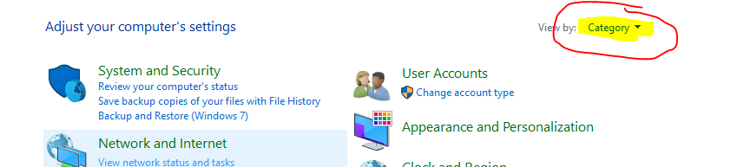
- From that list select Mail (Microsoft Outlook)
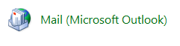
- From the box that opens up select Show Profiles
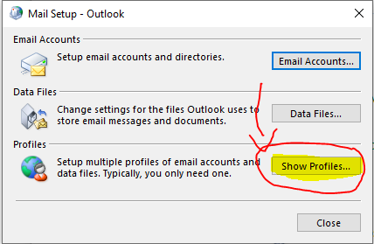
- Click the Add button and name the profile “Office 365” and click ok
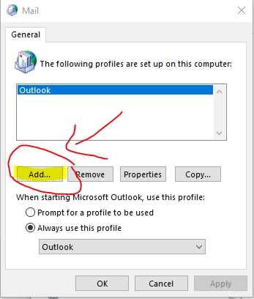
- What you see next depends on your Version of Outlook
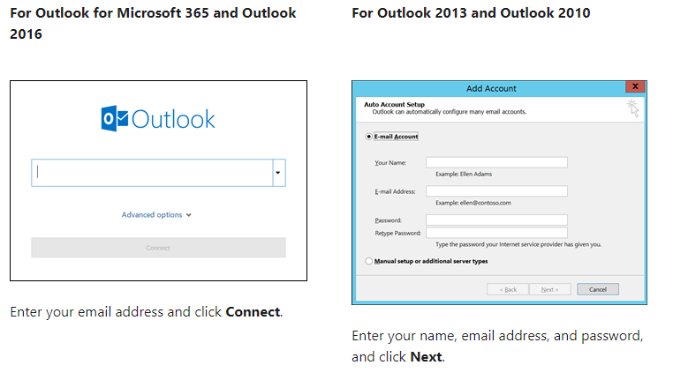
- Fill in the fields with your in I.E. Users@nt.nhsc.edu and your password
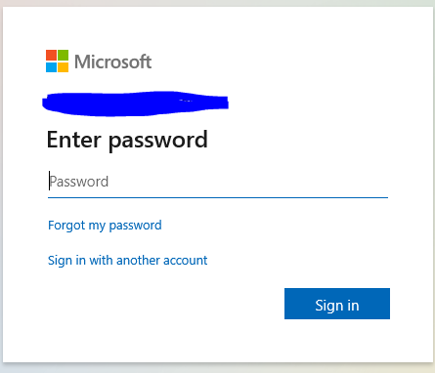
- After the account is setup remember to choose the office 365 account from the drop down menu labeled “always use this profile” on the mail tab. If you don’t do this the old profile will open when you open outlook.
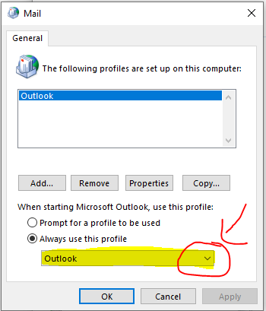
Setup for Android Samsung
- Navigate to Settings - > Accounts and Backup -> Manage Accounts -> Add account (If you have a non-Samsung phone you may need to look for the accounts section in a different area, also look for users and accounts)
- Choose the mail app you use (Outlook, Email)
- Enter you credentials.
Setup for Iphone
- Tap Settings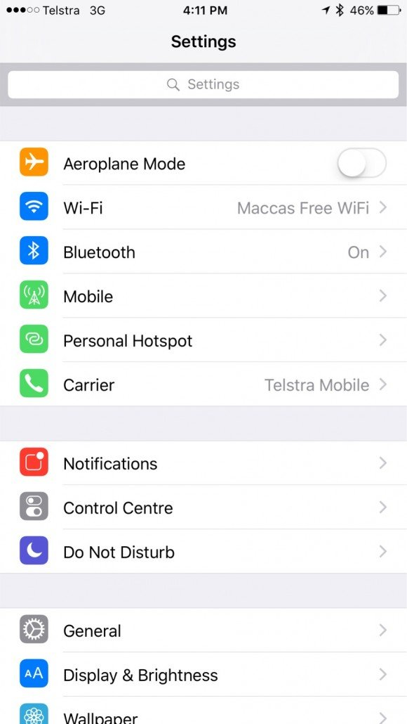
- Tap Mail, Contacts, Calendars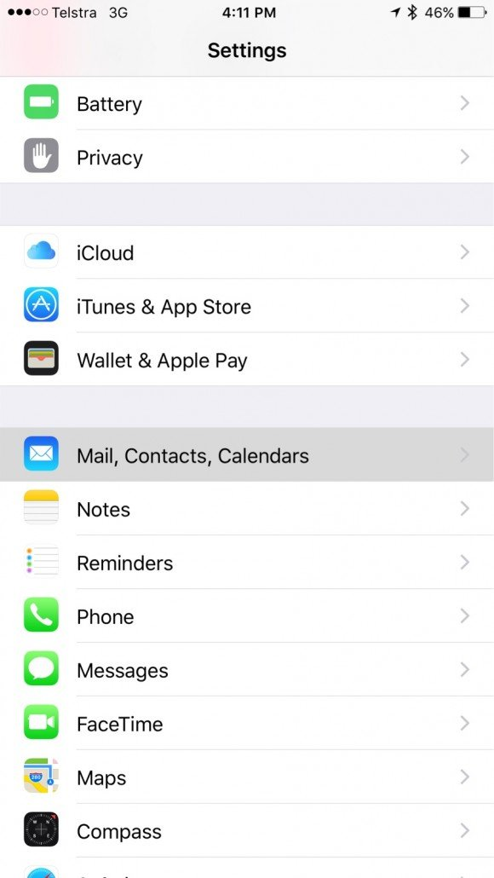
- Tap Add Account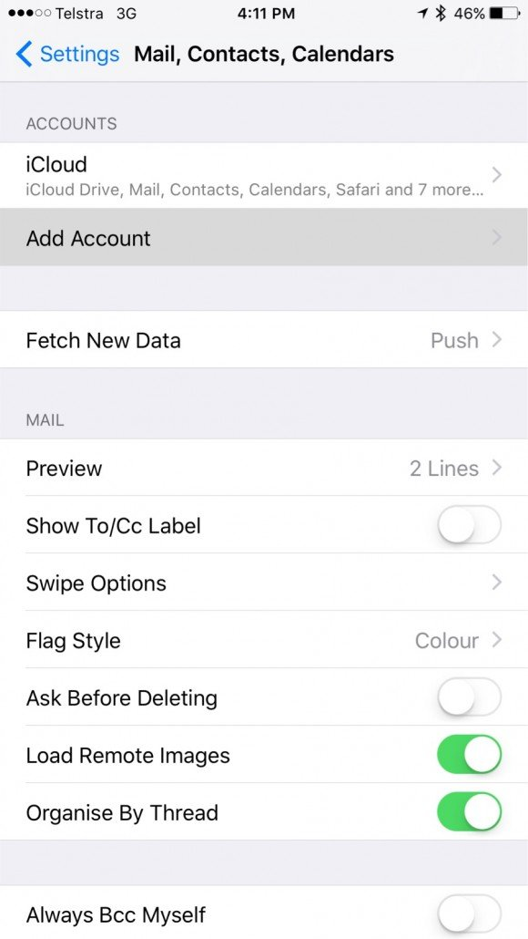
- Tap Exchange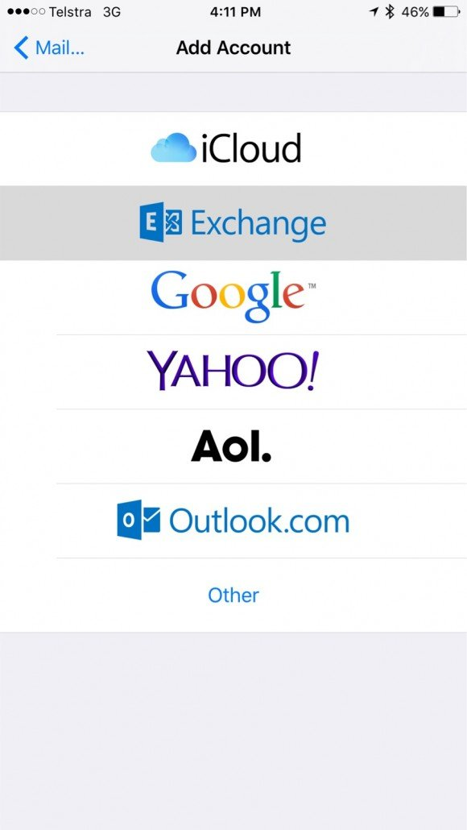
- Enter your Office 365 email address and password and tap Next.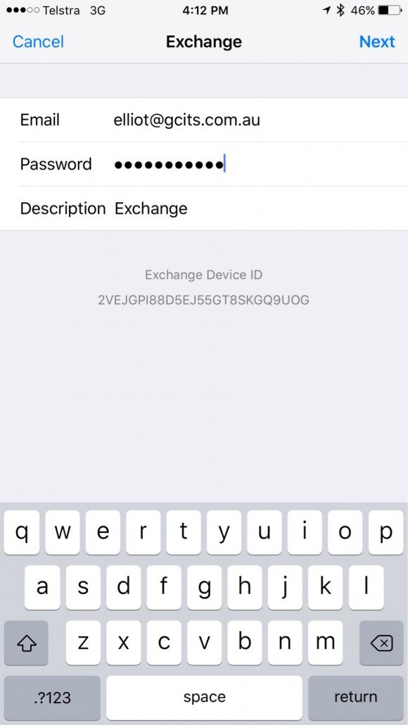
- Wait for it to show verified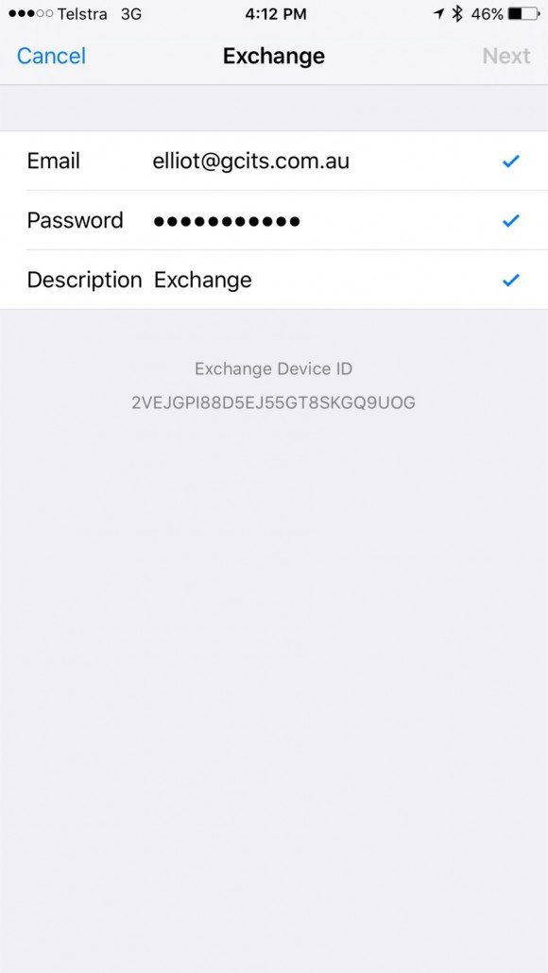
- Select the services you want to sync to your iPhone or iPad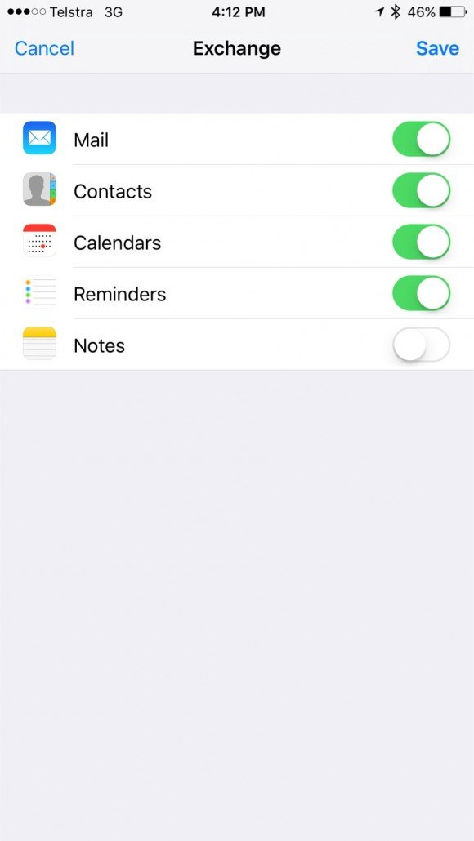
- Open the mail app on your phone to view your new mail account. Your Calendar will appear under the Calendar App, Contacts will appear under the Contacts app.

